Daphnia Growth Depending on Type of Salt

Introduction
Daphnia is a one of the common water fleas – found frequently in freshwater environments worldwide. Using Daphnia as a representative species in freshwater environments, we estimated the growth according to independent variable which is the different types of de-icing salts: NaCl, KCl, NaCl+KCl, and Yardworks Salt, with three dependent variables of Daphnia growth: pH, Dissolved Oxygen (DO, mg/L, and number of Daphnia alive after 2 days. NaCl application on roads are known for short- and long-term negative impacts on water and soil: it accelerates eutrophication of waters and causes high chloride concentrations in groundwater and soil. Excessive chlorides appear to decrease the growth of phytoplankton, especially cyanobacteria hence decrease the biodiversity of aquatic animals and plants. As NaCl is generally used as de-icing salts albeit its threat for freshwater ecosystem and groundwater migration, potassium chloride, mix of sodium and potassium chloride, and unpurified sodium chloride (Yardwork salt) were the other variables to contrast the growth of Daphnia in the control, pure water. The aim for this lab is to identify which salt-dissolved condition is most suitable for tiny freshwater creatures like Daphnia to live through measuring oxygen concentration, pH, and number of Daphnia alive after 2 days from the start of the conditioning. We hypothesized that Daphnia would grow better in water with dissolved potassium chloride (KCl) than other salts. This lab was held for 3 days; we predicted that after 48 hours, the salts will have increased mortality with this order: KCl, NaCl+KCl, Yardworks, NaCl.

Materials and Methods
The lab began from January 14 to 16th. On the first day, we followed the procedure of Daphnia lab in University of Guelph Marine and Freshwater Biology department. On the second day, we setup control, sodium chloride (NaCl), potassium chloride (KCl), mix of NaCl and KCl, Yarkworks salt 5 grams per Erlenmeyer flask filled with 1L of water. After waiting 15 minutes so that the salts are dissolved in the flasks, we designated 3 beakers for each independent variable. 10 Daphnia were designated to each beaker of about 200mL from the 5 Erlenmeyer flask which the salts were dissolved. The controlled variables were the environment in growth chamber, amount of water, and the number of Daphnia in each beaker set as 10 Daphnia per beaker with randomization to prevent bias. The temperature of the growth chamber was set as 20 degrees Celsius, with turning lights on and off in proper timing. Daphnia were growing without algae in beakers to control the environment equivalent to other beakers. We operated the growth chamber for two days. Below is the chart indicating the initial measurements of dependent variables.

The initials were calculated by taking the average of each result of 3 beakers per salt type. Prior to each measurement, we rinsed the DO measuring machine so that we don’t get any contamination and have completed pre-test with acidic (4.00), neutral (7.00), and base (10.0) solutions for accurate acidity analysis. Total of 15 beakers were used for this lab, and as in figure 1 in index, the salt types were distinguished by different colors of tape we attached to each beaker.

Results
After two days, on January 16th, we measured the dissolved oxygen concentration, pH, and number of Daphnia active.

Figure 1 Average measurements of dissolved oxygen concentration, acidity, and number of Daphnia active after conditioning 2 days in freshwater, NaCl-dissolved, mix of NaCl- and KCl-dissolved, KCl-dissolved, and rock salt-dissolved freshwater.
The mortality order is KCl, NaCl, NaCl+KCl, Yardworks, Control, which rejects the hypothesis. As observed in figure 1, The dissolved oxygen concentration, which the less is expected to indicate higher activity of Daphnia, appears to be similar in the five conditions. The dissolved oxygen measure is similar in NaCl+KCl and KCl while the number of active Daphnia are significantly different. However, NaCl showed the lowest number of Daphnia alive while conserving the highest dissolved oxygen. In terms of pH, Yardworks condition slightly showed a variance from control pH and others. At the same time, Yardworks showed the second-highest number of Daphnia alive followed by control group while indicating the lowest dissolved oxygen level.
Discussion
As we could not find a relationship between Daphnia alive after the lab and dissolved oxygen in the NaCl+KCl and KCl conditions, prospectively, we need future research that clearly diverges the two variables with significant distinction.

Index
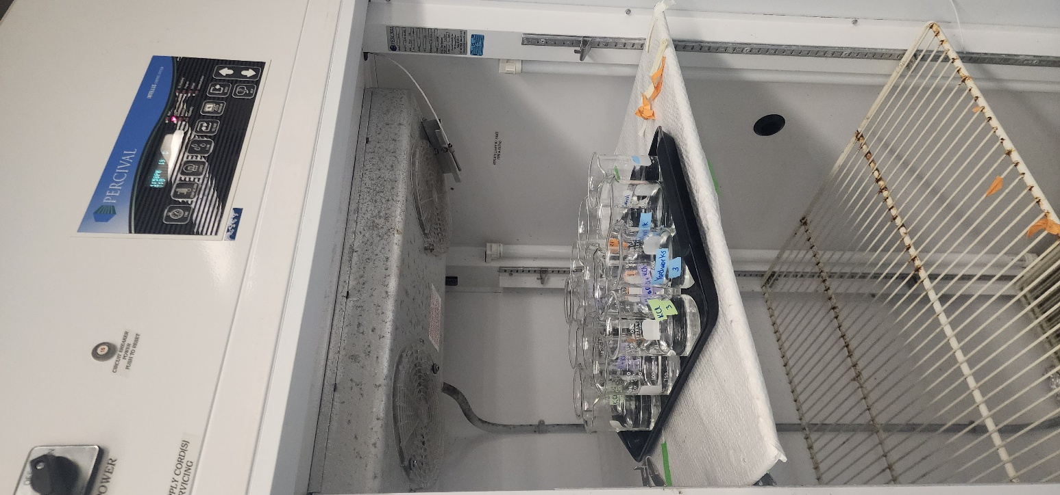
Figure 2 Beakers with 10 Daphnia each kept in growth chamber

